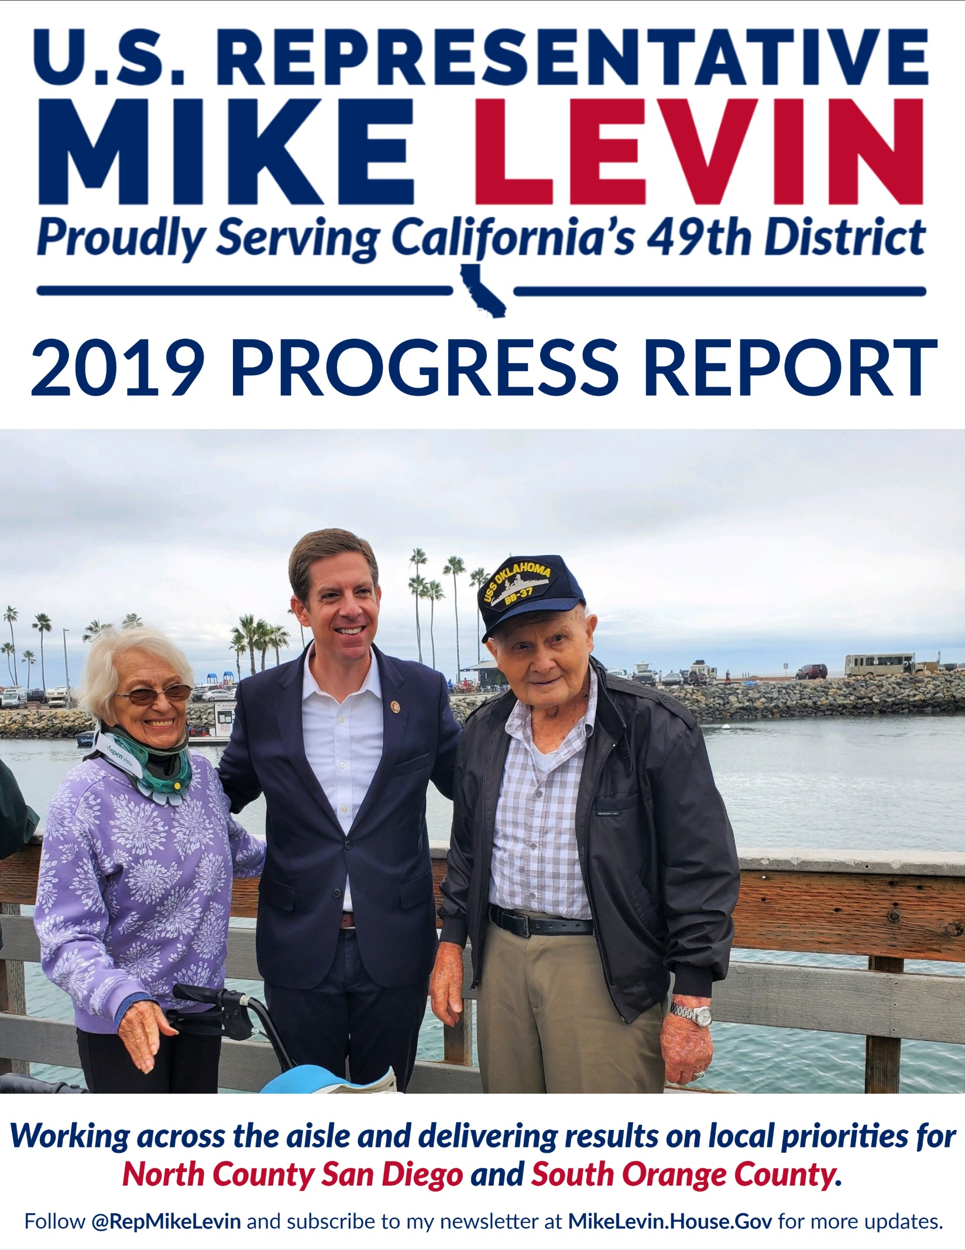
U.S Representative Mike Levin
Dear Neighbor,
It is an honor serving you as the U.S. Representative for California's 49th District. While my name may be on the door, this office really belongs to you, and I am doing everything I can to represent everyone who lives and works in our communities.
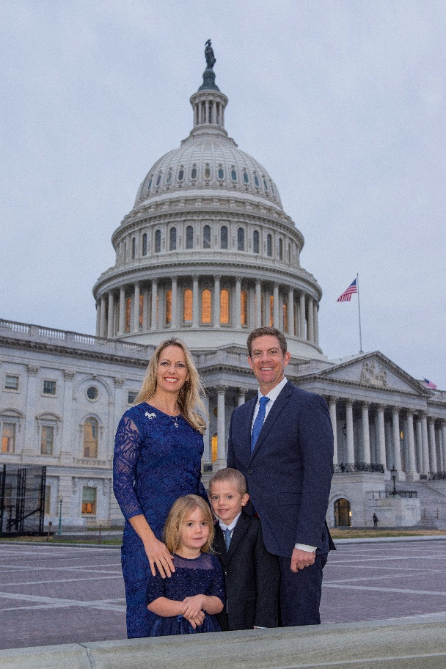
Since being sworn in on January 3, 2019, my number one priority has been working across the aisle to deliver results on local priorities for North County San Diego and South Orange County families.
As a member of the House Veterans’ Affairs Committee, Natural Resources Committee, and Select Committee on the Climate Crisis, I have worked with members of both parties to introduce 12 bipartisan bills, including nine that have passed the House of Representatives, and two that have been signed into law by the President.
I have also worked tirelessly to remain accessible and accountable to the people I serve. I have held 26 constituent coffees, responded to more than 50,000 constituent messages, and made over 80 visits to local businesses, schools, non-profit organizations and more.
Finally, one of the most important ways I can serve you is by helping resolve issues you may have with federal agencies. My staff in Oceanside and Dana Point have helped over 220 constituents with issues involving federal agencies. And since I was sworn in, various organizations in our district have received over $269 million in federal grants.
While we have made incredible progress in just one year, there is much more to be done. As long as I have the opportunity to serve you in Congress, I will continue to fight for your priorities every single day.
Thank you,
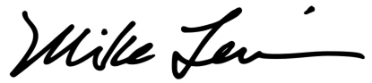
U.S. Representative Mike Levin (CA-49)
(Note: All information is current as of December 16, 2019)
Constituent Service by the Numbers
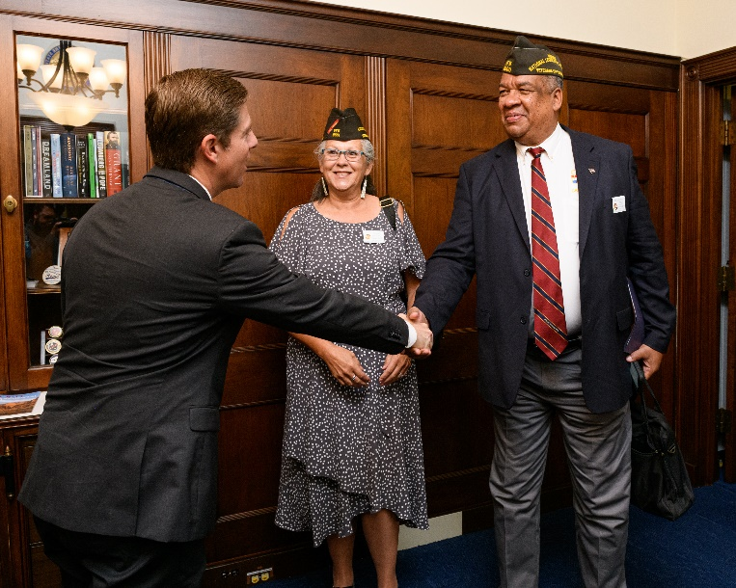
Organizations in the 49th District - like schools, non-profits, and research institutions - have received over $269,441,000 in federal grants since I was sworn into office.
My staff have closed more than 220 pieces of casework this year, resulting in more than $197,958 returned to constituents.
We have secured 26 medals, ribbons, and pins that local veterans earned during their service in the military.
We have also responded to over 50,000 messages from constituents and provided over 2,280 tours in Washington.
Here is a sample of our constituent success stories:
Daniel Fox, from Carlsbad: “Congressman Mike Levin and [staff] were able to achieve what accountants, lawyers and taxpayer advocates could not!”
Julian Joshua, from Dana Point: “Not everybody knows that one of the most important jobs of a US Representative is his or her role of facilitating interaction between constituents and the federal bureaucracy. This essential function has no connection with party politics. I have to give Mike Levin and his team top marks in this department.”
Danielle and Robert Chirco, from San Diego: “If it was not for the invaluable help and hard work from [staff] and Mr. Mike Levin, I believe that we would still be waiting for my husband’s backpay to this day, 10 months later. We are beyond grateful for what they accomplished for us.”
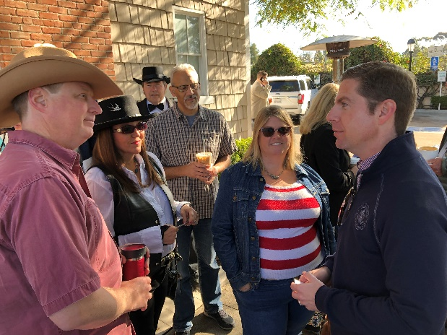
Our office produced more than 650 certificates of recognition to honor local individuals, organizations, and businesses for their contributions to our community.
I have had the honor of nominating 35 local students to attend U.S. service academies.
I have hosted 26 Constituent Coffees, both in the district and in Washington, where I provided updates on my work to address local priorities and took questions from constituents.
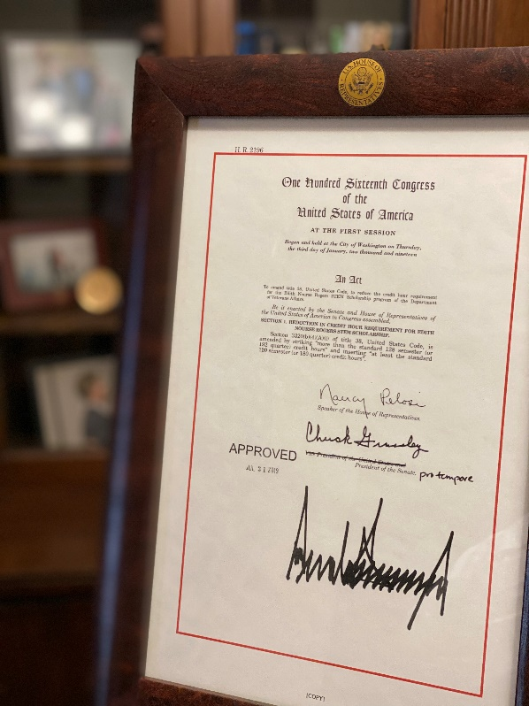
Legislative Accomplishments by the Numbers
My top priority is working across the aisle to deliver results on local priorities. I am proud to say that I have passed nine bipartisan bills through the House, including two that were signed into law by the President.
- Vet Center Eligibility Expansion Act to expand eligibility to receive counseling from VA Vet Centers.
- Protect Affordable Mortgages for Veterans Act to maintain liquidity in the veteran home loan market. (Signed into law)
- Veterans’ Education, Transition, and Opportunity Prioritization Plan (VET OPP) Act to prioritize economic programs at the VA.
- H.R. 2196 to expand veterans’ access to STEM scholarship programs. (Signed into law)
- Ryan Kules Specially Adaptive Housing Improvement Act to improve the VA's Specially Adapted Housing program.
- Fry Scholarship Improvement Act to expand Fry Scholarship eligibility, which passed as part of the Ryan Kules Specially Adaptive Housing Improvement Act.
- Navy SEAL Chief Petty Officer William "Bill" Mulder (Ret.) Transition Improvement Act to improve the Transition Assistance Program for servicemembers returning to civilian life.
- Housing for Women Veterans Act, which passed as part of the Deborah Sampson Act, to direct a portion of VA homelessness funding to women veterans.
- Protect the GI Bill Act to strengthen protections against predatory, for-profit schools.
Other Statistics:
- Introduced 32 bills, resolutions, or amendments, including 17 that were passed in the House.
  - Including 12 bipartisan bills, and three bipartisan resolutions or amendments
- Cosponsored 233 bills, resolutions, or amendments.
  - Including 131 bipartisan pieces of legislation
- Participated in all 682 votes by the House.
- Attended 80 committee hearings, roundtables, and markups.
Other Legislative Highlights
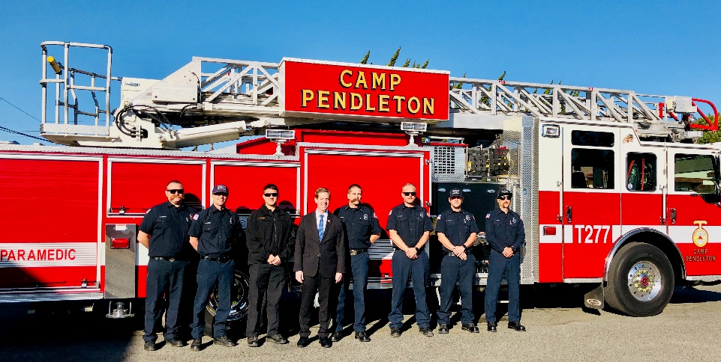
- Secured $128 million in military construction funding for Marine Corps Base Camp Pendleton in the National Defense Authorization Act (NDAA).
- First bill introduced: The bipartisan Ensuring Safe Housing for our Military Act to increase accountability and oversight over private housing for military families, which has suffered from serious health, safety, and environmental problems. Proposals from this legislation were included in the NDAA.
- Negotiated for $300 million in federal funding to be included in the United States–Mexico–Canada Agreement (USMCA) for the Border Water Infrastructure Program, which will address pollution in the Tijuana River Valley.
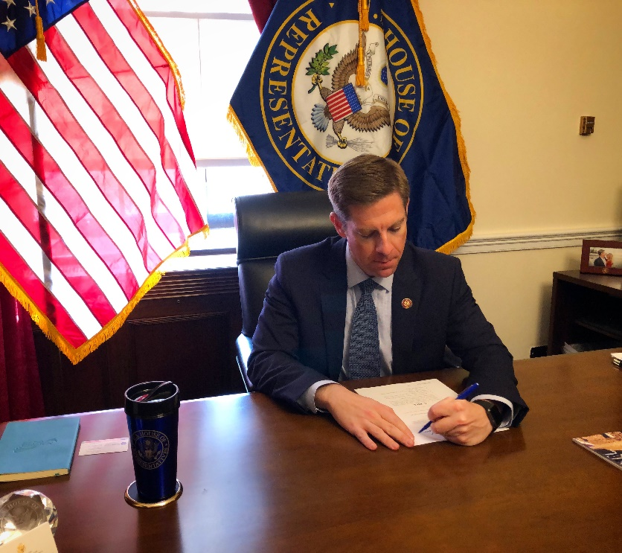
- Introduced bipartisan legislation to help reduce gun violence - including suicide and accidental shootings - by providing a modest tax credit for retailers to incentivize the sale of safe storage devices for firearms.
- Introduced the Spent Fuel Prioritization Act to prioritize the removal of spent nuclear fuel from decommissioned nuclear sites in areas with large populations and high seismic hazard, such as the San Onofre Nuclear Generating Station (SONGS).
- Introduced bipartisan legislation to help combat the climate crisis and reduce our dependence on fossil fuels by promoting development of wind, solar, and geothermal energy on public lands.
- Passed legislation to invest billions in the National Institutes of Health (NIH) for scientific research related to antibiotic resistance and rare diseases as part of the Lower Drug Costs Now Act of 2019 (H.R. 3).

Contact Our Offices
